24BAD405-NISHANTH P
Challenge Name: Volume Calculator
Description: Use function overloading to calculate the volume of different 3D shapes.
Problem Statement:
Volume is computed differently for cubes, spheres, and cylinders. Instead of creating multiple function names, function overloading allows a single volume() function with different parameter lists.
The program should support cube (side), sphere (radius), and cylinder (radius, height).
Input Format:
- Shape type and required parameters.
Constraints:
- Dimensions > 0
Output Format:
- Print volume.
Test Cases:
- cube 3 → 27
- sphere 2 → 33.51
- cylinder 3 5 → 141.37

Code:
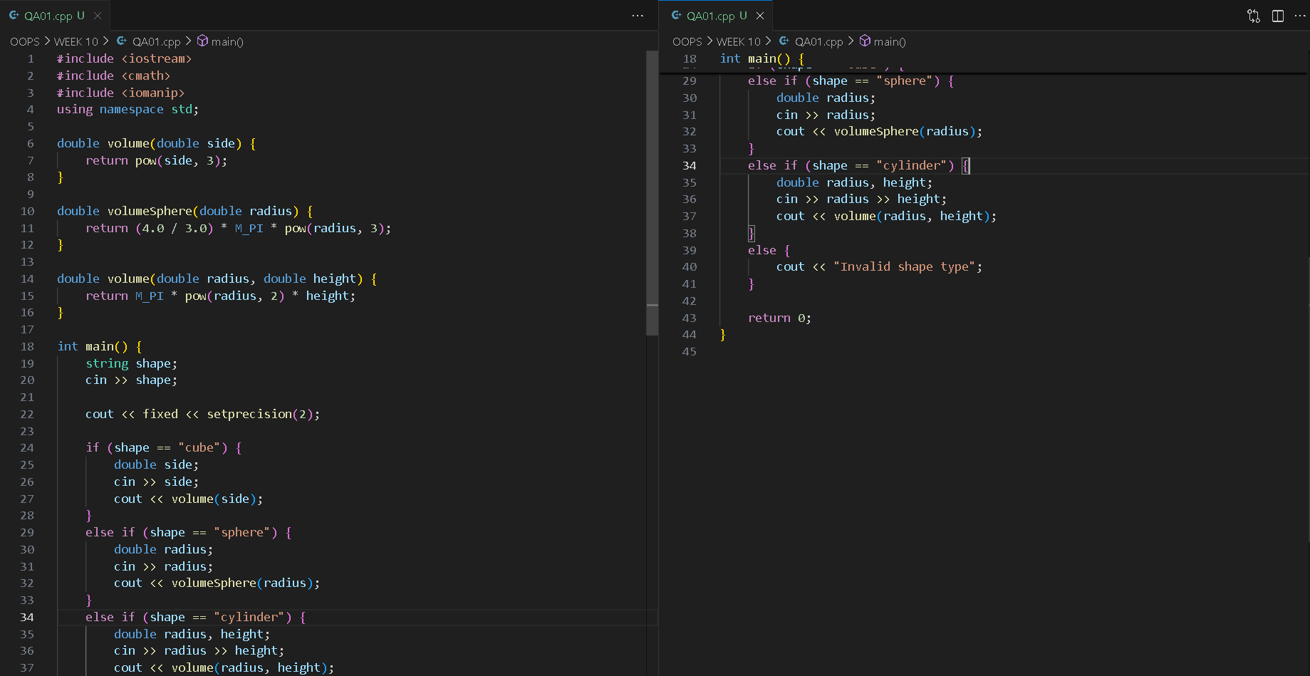
Output:
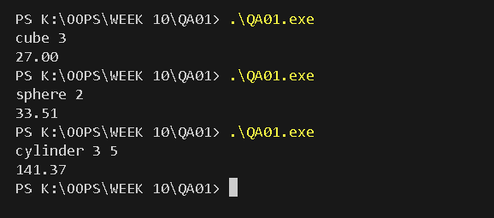

Challenge Name: Power Calculator
Description: Use function overloading to compute powers of integers and doubles.
Problem Statement:
Exponential calculations are frequent in mathematics. While integers and doubles may be handled separately, we can overload power() for both data types.
One function should take (int, int) while another takes (double, int).
Input Format:
- Base and exponent.
Constraints:
- Exponent ≥ 0
Output Format:
- Print the result.
Test Cases:
- int 2 3 → 8
- double 2.5 2 → 6.25
- int 5 0 → 1

Code:
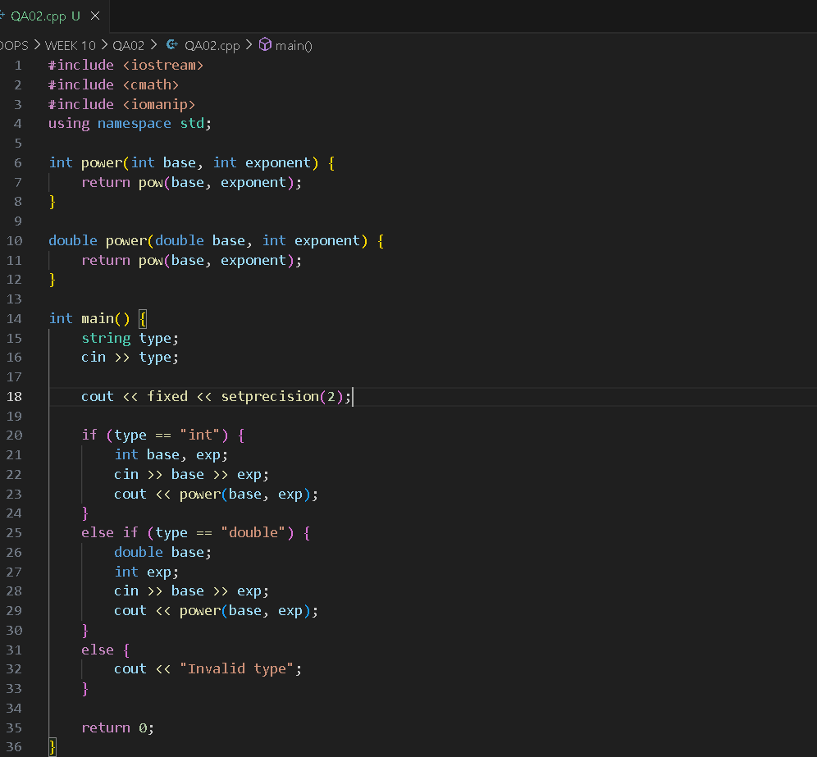
Output:
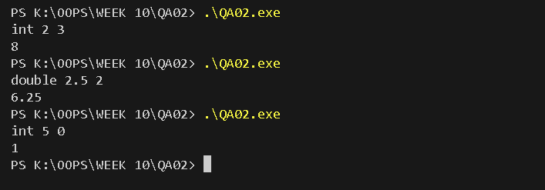

Challenge Name: Max Finder
Description: Overload functions to find maximum of two or three numbers.
Problem Statement:
Comparisons are common in applications like leaderboards or stock analysis. Overloading allows us to extend a single maxValue() function to handle two or three parameters.
You must implement maxValue(int, int) and maxValue(int, int, int).
Input Format:
- Integers.
Constraints:
- Inputs within int range.
Output Format:
- Print maximum value.
Test Cases:
- 2 5 → 5
- 10 20 15 → 20
- 7 7 → 7

Code:
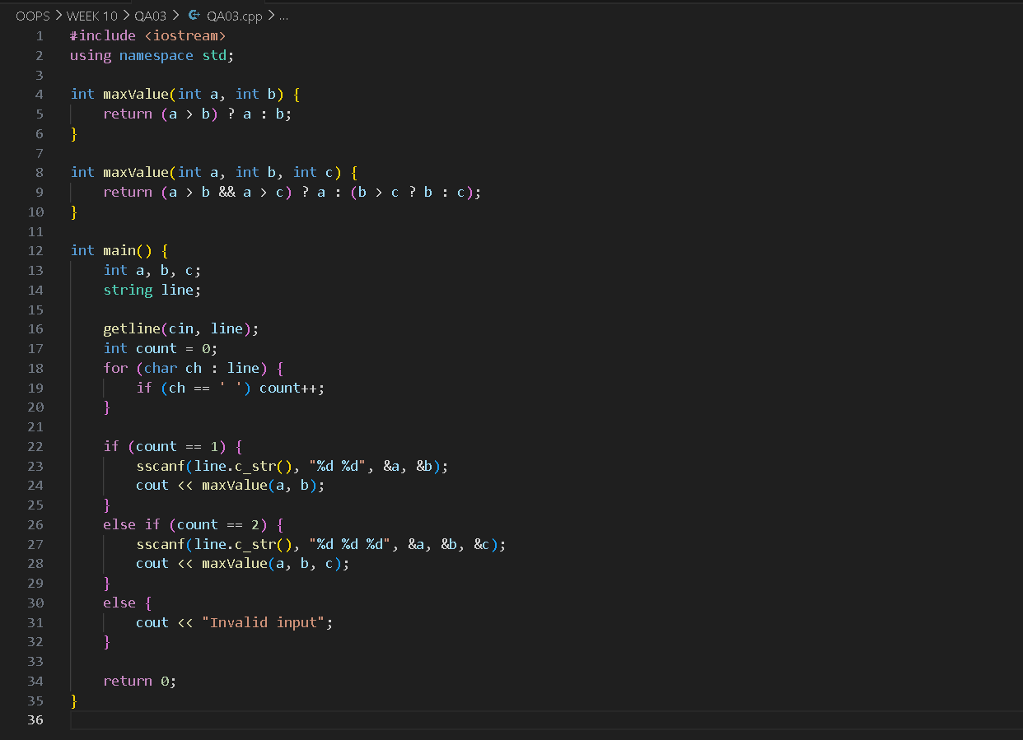
Output:
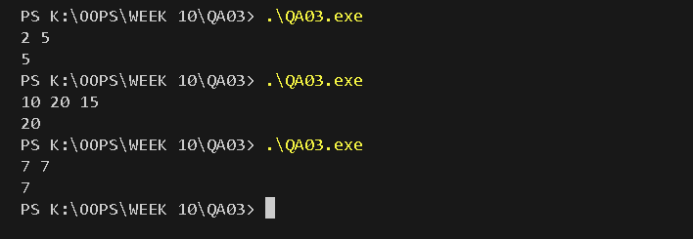

Challenge: Travel Package Planner
Problem Statement
Travel agencies often provide flexible packages for customers. Some customers may only book a destination, while others may book a destination along with the number of days, and a few may even include the type of accommodation they want. Constructor overloading helps manage these scenarios without writing separate classes for each case.
You are tasked with creating a TravelPackage class where:
- Constructor 1 accepts only the destination.
- Constructor 2 accepts destination and number of days.
- Constructor 3 accepts destination, days, and accommodation type.
This allows the system to create travel plans for customers with varying preferences. The class should include a method to display the complete package details.
Input Format
- Destination
- Number of days (or -1 if not provided)
- Accommodation type (or NA if not provided)
Constraints
- Destination: string (max length 50)
- Days: positive integer or -1
- Accommodation: string or NA
Output Format
- Display the travel package details.
Test Case 1
Paris
5
Hotel
Output:
Destination: Paris
Days: 5
Accommodation: Hotel
Test Case 2
Goa
-1
NA
Output:
Destination: Goa
Days: Not Provided
Accommodation: Not Provided
Test Case 3
Tokyo
7
NA
Output:
Destination: Tokyo
Days: 7
Accommodation: Not Provided

Code:
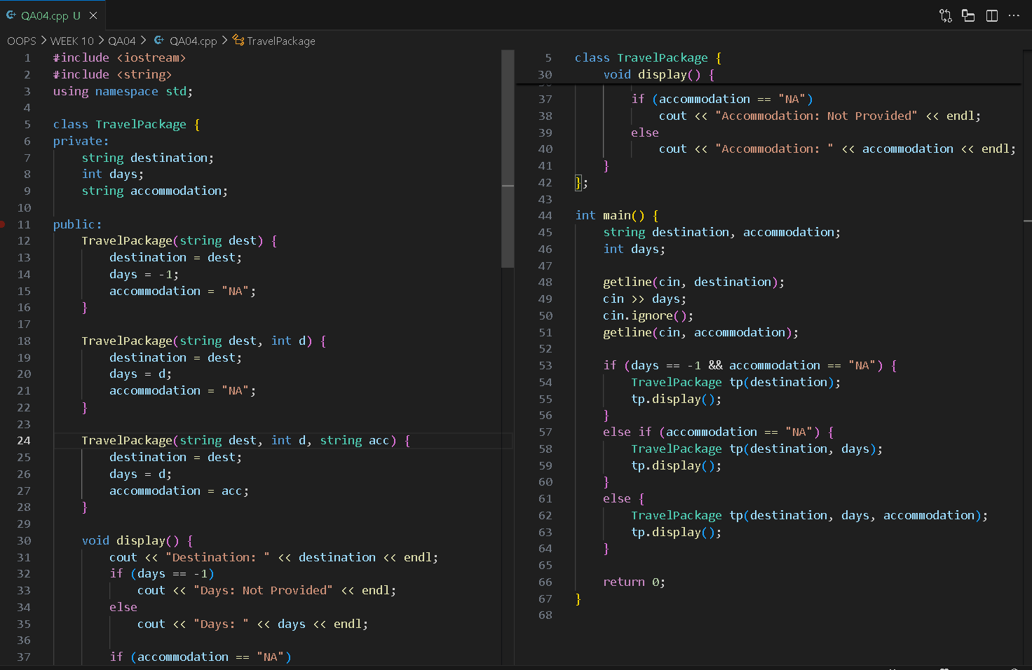
Output:


Gym Membership System
Problem Statement
Gyms often provide memberships with varying details. Some users register only with a name, others provide a name and duration in months, and some also include the type of plan (basic, premium). Instead of forcing customers to always provide full details, constructor overloading simplifies registration.
You need to implement a Membership class with three constructors:
- Name only
- Name + Duration
- Name + Duration + Plan
A method showMembership() should print the membership details.
Input Format
- Name
- Duration (or -1 if not provided)
- Plan (or NA if not provided)
Constraints
- Name: string (≤ 50 chars)
- Duration: integer ≥ 1 or -1
- Plan: string (≤ 20 chars) or NA
Output Format
- Display membership details.
Test Case 1
Karan
12
Premium
Output:
Name: Karan
Duration: 12 months
Plan: Premium
Test Case 2
Neha
-1
NA
Output:
Name: Neha
Duration: Not Provided
Plan: Not Provided
Test Case 3
Amit
6
NA
Output:
Name: Amit
Duration: 6 months
Plan: Not Provided

Code:
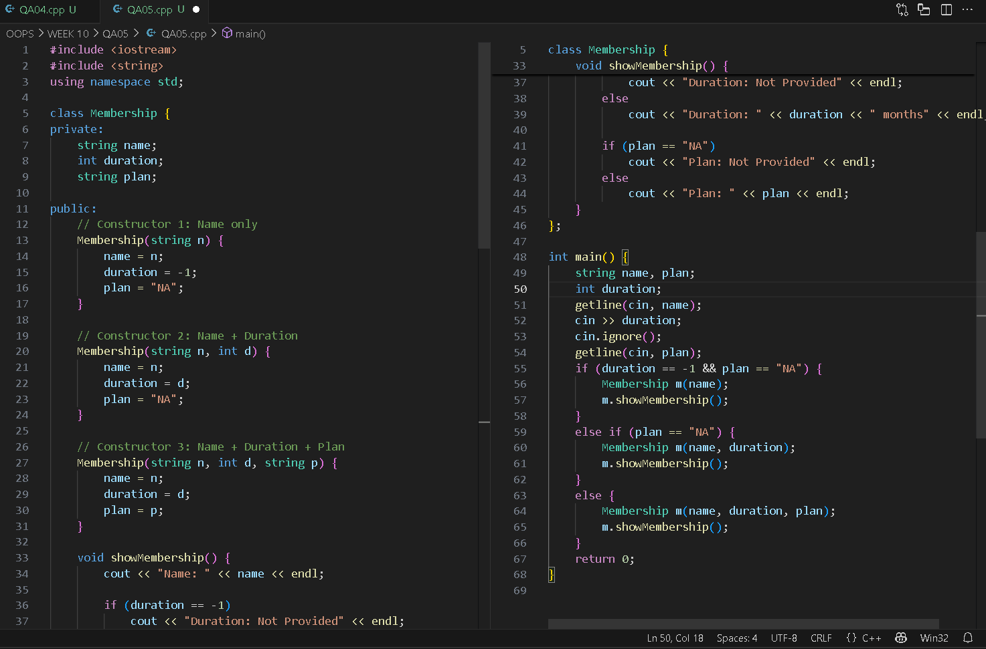
Output:


